Website Design Rubric for the OLMCS Sports Page 50 Points Possible
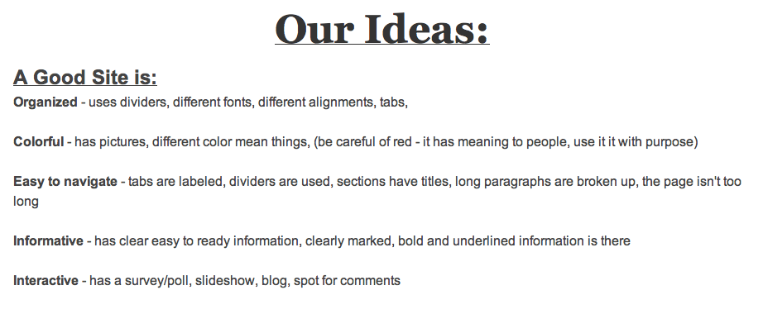

50 Point Break Down

Organized _______10 pts
Colorful _______10 pts
Is Interactive _______10 pts
Error Free _______10 pts

Has a Link _______2 pts
Has a Column _______2 pts
Has 1 photo _______2 pts
Has a divider _______2pts
Has tabs _______2 pts
Total out of 50 ____________/50 Points

